Using Distributed cache join the two datasets and find out the number of temperature variations in each country using mapreduce.

**Driver class:**

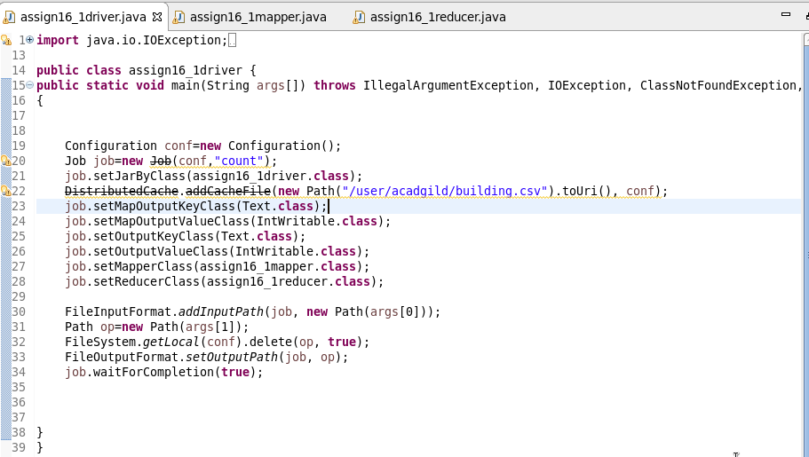

**Mapper class:**

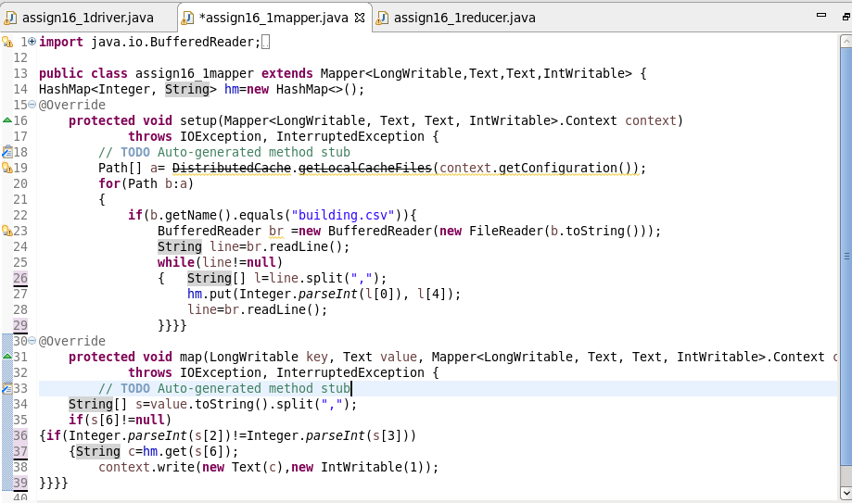

**Reducer class:**

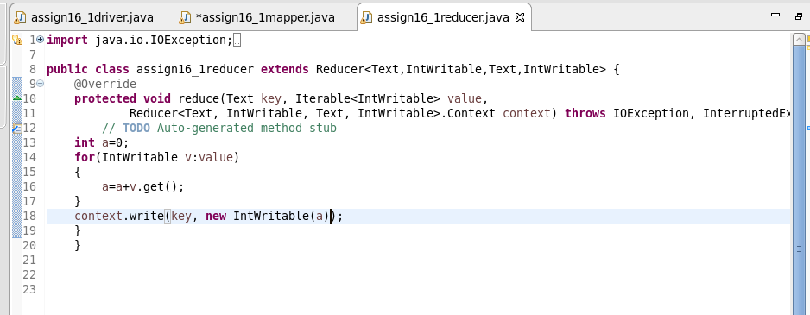

**RUNNING JAR:**



**OUTPUT:**

